Pork Pie Ingredients, Nutrition information & Allergen list
18/03/19

USED WITHIN 5 days of receiving the product
Must be kept between 3-5 degrees
Do not freeze

Ingredients:
Flour (Wheat)
Milk
Water
Stock MILK
Spices
Lard
Pork Meat
Gelatin
Egg

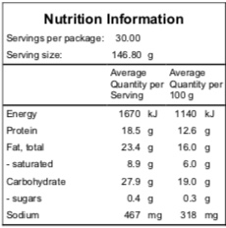

Allergens:
Wheat Flour
Milk
Egg

Made on equipment that also processes products containing fish, soybean, peanuts and sesame.

